

## Test Two

## Semester One 2017 UNIT 1 METHODS

## Calculator Free 35 minutes /30 marks

## Only Formula Sheet Permitted

**Name:**

Place a tick in the box next to your Mathematics teachers name:

|  |  |
| --- | --- |
| **Mr Strain** | **□** |
| **Ms Sindel** | **□** |
| **Ms Rimando** | **□** |
| **Ms Reynolds** | **□** |
| **Dr Pearce** | **□** |
| **Mrs Flynn** | **□** |
| **Ms Ensly** | **□** |
| **Mrs Carter** | **□** |

**Question 1**  **(3, 3 = 6 marks)**

Find the equation of each linear function

1. Passing through (2,-3) and (4,1)
2. Perpendicular to the line 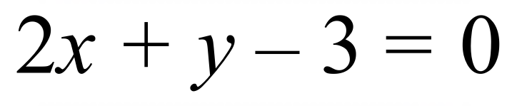 and with *x*-intercept of -2.

**Question 2 (2 marks)**

Given the points (-3, 1) and (4, 2) find the **exact value** of the distancebetween them.

**Question 3** **(2 marks)**

The gradient of the straight line between (3, y) and (-2, 5) is 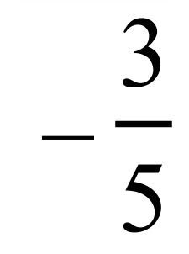 . Find the value of y.

**Question 4 (1, 1 = 2 marks)**

The quadratic equation 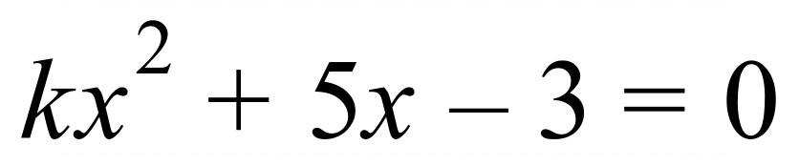 has exactly one real solution.

1. What is the value of the discriminant?
2. Hence, find the value of *k*.

**Question 5 (2, 2 = 4 marks)**

Solve the following quadratic equations giving exact answers

a) 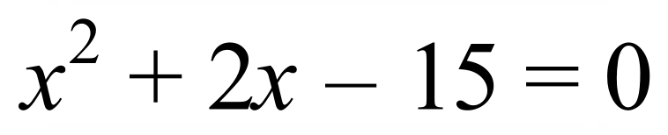

b) 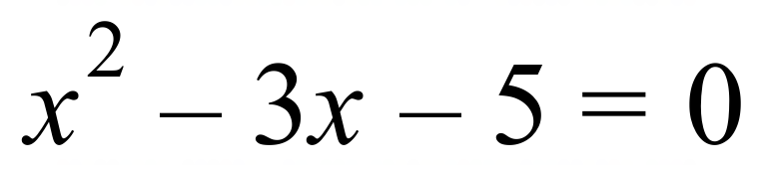

**Question 6 (2, 5 = 7 marks)**

Determine the rules for the following tables

a)

|  |  |  |  |  |  |
| --- | --- | --- | --- | --- | --- |
| ***x*** | **-7** | **-6** | **-5** | **-4** | **-3** |
| ***y*** | 11 | 10 | 9 | 8 | 7 |

b)

|  |  |  |  |  |  |  |  |
| --- | --- | --- | --- | --- | --- | --- | --- |
| ***x*** | **1** | **2** | **3** | **4** | **5** | **6** | **7** |
| ***y*** | 2 | 2 | 4 | 8 | 14 | 22 | 32 |

Question 7 (3, 2, 2 = 7 marks)

(a) Part of the graph of  is shown below.

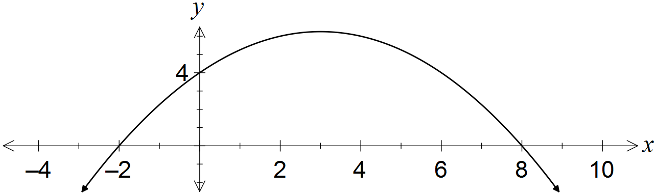

Determine the values of the coefficients a and b.

(b) A quadratic has equation . Determine

(i) the coordinates of its turning point.

(ii) the exact values of the zeros of the quadratic.